Social Studies – Chapter 1
Study Guide

“Where Am I?”
Hemispheres, Continents, Oceans, Etc!
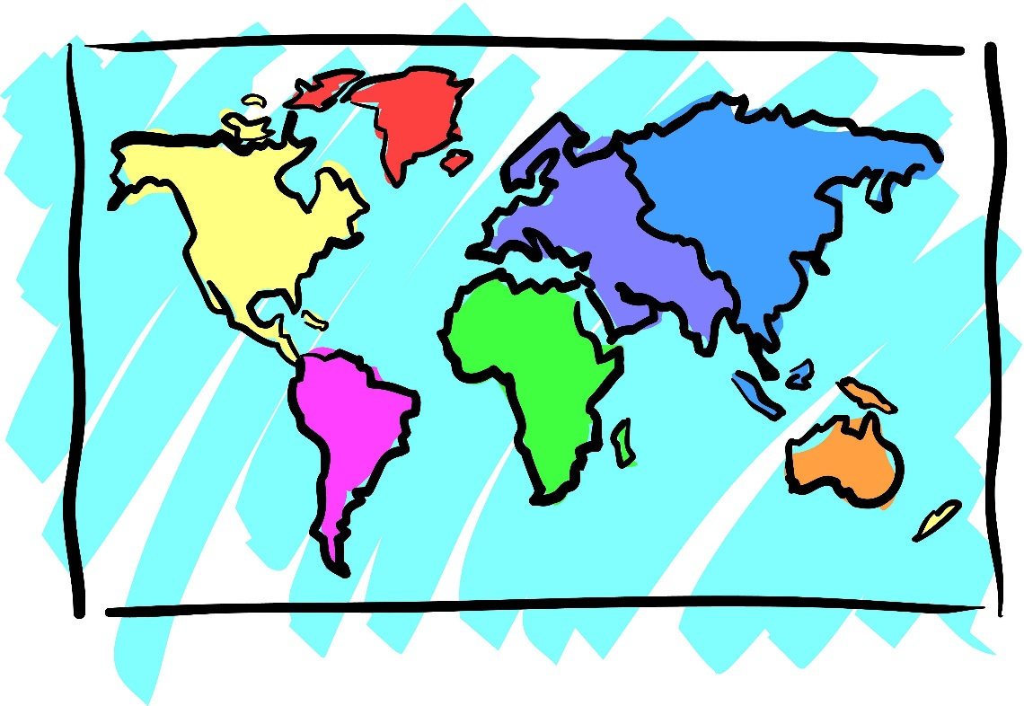

Test Date: _____________________

Name: ________________________

Match the letter to the correct definition.

1. continent __________ 5. ocean __________

2. equator __________ 6. border __________

3. country _________ 7. prime meridian _________

4. geography __________ 8. city __________

A. an area of land that has its own government
B. the study of Earth and its land, water, and people
C. one of the 7 largest bodies of land on Earth
D. this marks the end of one country and the beginning of another
E. the imaginary line that divides the Earth into the Northern and Southern Hemispheres.
F. a larger community with many people and lots of buildings
G. one of the 4 largest bodies of water on Earth
H. the imaginary line that divides the Earth into the Eastern and Western Hemispheres

Label the compass rose. Use capital letters.
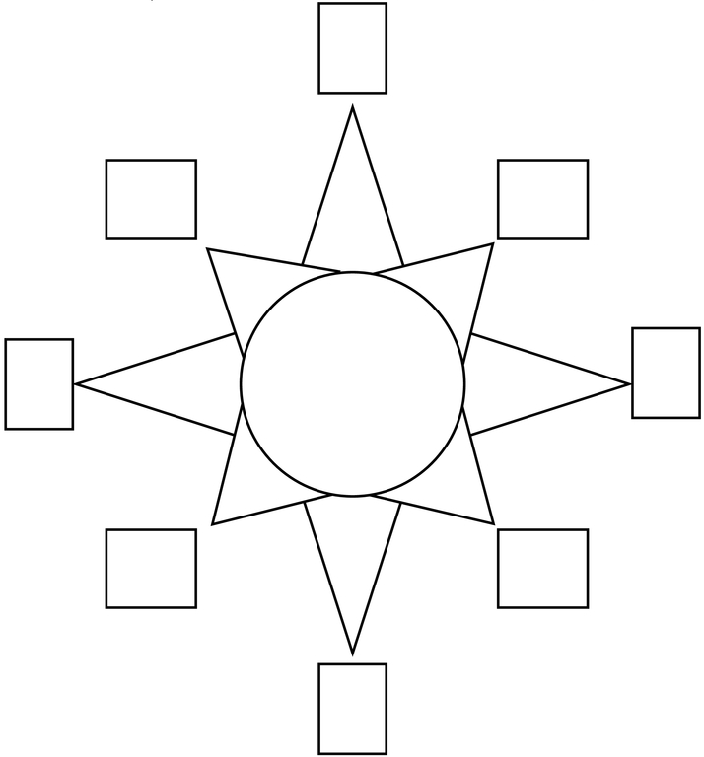

Tell me the color for each if you were looking at Earth from outer space.
Clouds Water Land
____________ ____________ ____________

Complete the following. Use the word bank to help you.

Pennsylvania United States Atlantic Ocean Pittsburgh North America

Our Continent: _________________________
Our Country: _________________________
Our State: _________________________
Our City: _________________________
Closest Ocean to Us: _________________________

Label the 4 hemispheres. (Northern, Southern, Eastern, Western)
A. _________________________
B. _________________________
C. _________________________
D. _________________________
Circle the 2 hemispheres we live in! (A, B, C, D)

1. Trace the equator with a red crayon.
2. Trace the prime meridian with a blue crayon
3. Name two continents the equator passes through.
_______________ _______________
4. Name one continents the prime meridian passes through.
_______________
5. Which continent is entirely in the Southern Hemisphere?
_______________
6. Which ocean is entirely in the Northern Hemisphere? _______________

